Let us start with the below equality obtained using phasor formula, that is

|  |  |
| --- | --- |
| $$\sum_{k=1}^{N}{\cos\left(θ+\left(k-1\right)ϕ\right)}=\frac{\sin\left(\frac{Nϕ}{2}\right)⁡}{\sin\left(\frac{ϕ}{2}\right)}\cos\left(θ+\frac{(N-1)ϕ}{2}\right)$$ | (1) |

where substituting both $θ=2πf_{c}t+2πf_{m}t^{2}+ϕ_{0}$ and $ϕ=2πf_{m}t$ with chirp frequency component $2πf_{m}t^{2}$ yields

$$\sum_{k=1}^{N}{\cos\left(2πf_{c}t+2πf_{m}t^{2}+2π\left(k-1\right)f_{m}t+ϕ_{0}\right)}=\frac{\sin\left(Nπf_{m}t\right)⁡}{\sin\left(πf_{m}t\right)}\cos\left(2πf_{c}t+2πf_{m}t^{2}+\left(N-1\right){πf}_{m}t+ϕ_{0}\right) \\ =\frac{Nπf_{m}t\frac{\sin\left(Nπf_{m}t\right)}{Nπf_{m}t}⁡}{πf_{m}t\frac{\sin\left(πf_{m}t\right)}{πf_{m}t}}\cos\left(2πf_{c}t+2πf_{m}t^{2}+\left(N-1\right){πf}_{m}t+ϕ_{0}\right) \\ =N\frac{\frac{\sin\left(Nπf_{m}t\right)}{Nπf_{m}t}⁡}{\frac{\sin\left(πf_{m}t\right)}{πf_{m}t}}\cos\left(2πf_{c}t+2πf_{m}t^{2}+\left(N-1\right){πf}_{m}t+ϕ_{0}\right) \\ =N\frac{\operatorname{sinc}\left(Nf_{m}t\right)⁡}{\operatorname{sinc}\left(f_{m}t\right)}\cos\left(2πf_{c}t+2πf_{m}t^{2}+\left(N-1\right){πf}_{m}t+ϕ_{0}\right) \\ =g_{T}\left(t\right)\cos\left(2πf_{c}t+2πf_{m}t^{2}+\left(N-1\right){πf}_{m}t+ϕ_{0}\right) \\ =g_{T}\left(t\right)\cos\left(2πf_{c}t+2πf_{m}t^{2}+2πβ_{m}t+ϕ_{0}\right)$$

where $2πβ_{m}=\left(N-1\right){πf}_{m}.$ In case of Doppler existence within the channel, the total received signal is

$$\sum_{k=1}^{N}{\cos\left(2πf_{c}t+2πf_{m}t^{2}+2πf_{d,k}t+2π\left(k-1\right)f_{m}t+ϕ_{0}\right)}$$

where $f_{d,k}$ denotes Doppler’s frequency defined as a function $f_{d,k}=g(k,v,f_{c},f_{m})$.

1. How to obtain Equation (1)?
$$\sum_{k=1}^{N}{\cos\left(θ+\left(k-1\right)ϕ\right)}=\frac{1}{2}\left[\sum_{k=1}^{N}{e^{i\left(θ+\left(k-1\right)ϕ\right)}}+e^{-i\left(θ+\left(k-1\right)ϕ\right)}\right]$$

$$=\frac{1}{2}\left[\sum_{k=1}^{N}{{e^{iθ}e}^{i\left(k-1\right)ϕ}}+e^{-iθ}e^{-i\left(k-1\right)ϕ}\right]$$

$$=\frac{1}{2}\left[\sum_{m=0}^{N-1}{{e^{iθ}e}^{imϕ}}+e^{-iθ}e^{-imϕ}\right]$$

$$=\frac{e^{iθ}}{2}\left[\frac{1-e^{iNϕ}}{1-e^{iϕ}}\right]+\frac{e^{-iθ}}{2}\left[\frac{1-e^{-iNϕ}}{1-e^{-iϕ}}\right]$$

$$=\frac{e^{iθ}e^{\frac{iNϕ}{2}}}{2e^{\frac{iϕ}{2}}}\left[\frac{e^{\frac{-iNϕ}{2}}-e^{\frac{iNϕ}{2}}}{e^{\frac{-iϕ}{2}}-e^{\frac{iϕ}{2}}}\right]+\frac{e^{-iθ}e^{\frac{-iNϕ}{2}}}{2e^{\frac{-iϕ}{2}}}\left[\frac{e^{\frac{iNϕ}{2}}-e^{\frac{-iNϕ}{2}}}{e^{\frac{iϕ}{2}}-e^{\frac{-iϕ}{2}}}\right]$$

$$=\frac{1}{2}e^{i\left(θ+\frac{\left(N-1\right)ϕ}{2}\right)}\frac{\left(-2isin\left(\frac{Nϕ}{2}\right)\right)}{\left(-2isin\left(\frac{ϕ}{2}\right)\right)}+\frac{1}{2}e^{-i\left(θ+\frac{\left(N-1\right)ϕ}{2}\right)}\frac{\left(2isin\left(\frac{Nϕ}{2}\right)\right)}{\left(2isin\left(\frac{ϕ}{2}\right)\right)}$$

$$=\frac{sin\left(\frac{Nϕ}{2}\right)}{sin\left(\frac{ϕ}{2}\right)}\left[\frac{e^{i\left(θ+\frac{\left(N-1\right)ϕ}{2}\right)}+e^{-i\left(θ+\frac{\left(N-1\right)ϕ}{2}\right)}}{2}\right]$$

$$= \frac{\sin\left(\frac{Nϕ}{2}\right)⁡}{\sin\left(\frac{ϕ}{2}\right)}\cos\left(θ+\frac{(N-1)ϕ}{2}\right)$$

2. How to approximate the pulseshape $g_{T}\left(t\right)$?

$$g_{T}\left(t\right)= \left\{\begin{aligned}N\frac{\operatorname{sinc}\left(Nf_{m}t\right)⁡}{\operatorname{sinc}\left(f_{m}t\right)} ,-a<t<a \\ 0 , otherwise\end{aligned}\right.$$

Where $N\frac{\operatorname{sinc}\left(Nf_{m}a\right)⁡}{\operatorname{sinc}\left(f_{m}a\right)}=0.1N$. This expression corresponds to the time where $g_{T}\left(t\right)$ has a value of %10. However, we concluded that $g_{T}\left(t\right)$ neither convergent nor finite as seen in Figure 1.

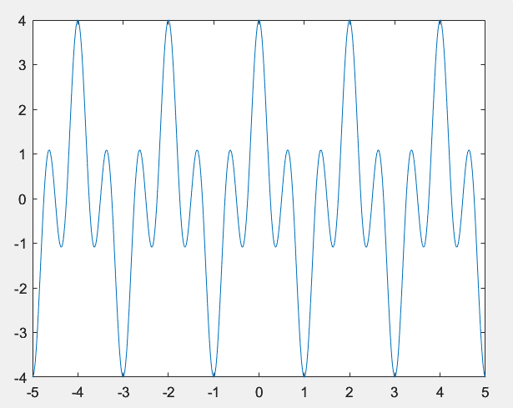

Figure 1. Time plot of g_T(t)

The parameters used to interpret Figure 1 are as follows:

N = 4; *fm*=1;

1. In case of Doppler shift existence:

Phase of signal: $ϕ_{T}=2πf_{c}t+2πf_{m}t^{2}+2π\left(k-1\right)f_{m}t+ϕ_{0}$

Instantaneous angular frequency of signal: $ω_{T}=\frac{dϕ_{T}}{dt}= 2πf_{c}+4πf_{m}t+2π\left(k-1\right)f_{m}$

Instantaneous frequency of signal: $f_{T}=f_{c}+2f_{m}t+\left(k-1\right)f_{m}$

Doppler frequency shift: $f_{observed}=\frac{f_{T}v}{c-v}=\frac{{(f}_{c}+2f_{m}t+\left(k-1\right)f_{m})v}{c-v}$